**East West University Department of CSE**

**LAB REPORT**

|  |  |  |
| --- | --- | --- |
| **Course Code and Name:**  CSE209 - Electrical Circuit | | |
| **Experiment no: 05** | | |
| **Experiment name:**  To verify the superposition theorem theoretically, experimentally, and using PSpice simulation. | | |
| **Semester and Year:**  Fall 2021 |  | |
| **Name of Student:**  D.M. Rafiun Bin Masud  **Student Id:**  2019-3-60-137 | **Course Instructor information:**  M Saddam Hossain Khan  Senior Lecturer  Department of Computer Science and Engineering | |
| **Date of Report Submitted:**  Dec 26, 2021 | **Pre-Lab Marks:** |  |
| **Post Lab Marks:** |  |
| **TOTAL Marks:** |  |

**Objective:**

To verify the superposition theorem theoretically, experimentally, and using PSpice simulation.

We know that the superposition theorem states in a linear circuit with several sources, the current and voltage for any element in the circuit is the sum of the currents and voltages produced by each source acting independently.

**Simulation circuits using PSpice:**

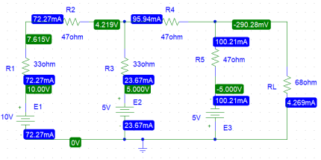 Figure 1: Circuit with all sources active.

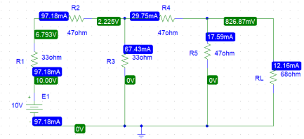Figure 2: Circuit with E1 sources active.

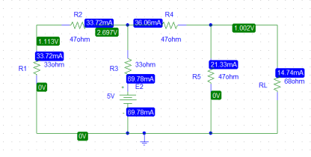Figure 3: Circuit with E2 sources active. 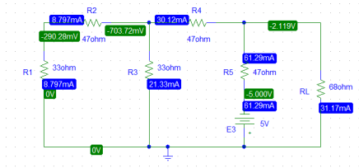 Figure 4: Circuit with E3 source active.

Table 1. Experimental Datasheet.

|  |  |  |  |  |  |  |  |
| --- | --- | --- | --- | --- | --- | --- | --- |
| Simulated Value of  *E*1 (V) | Simulated Value of  *E*2 (V) | Simulated Value of  *E*3 (V) | Simulated value of  *IL* with all sources  active  (mA) | Simulated value of  *IL*1 with  only *E*1  active  (mA) | Simulated value of  *IL*2 with  only *E*2  active  (mA) | Simulated value of  *IL*3 with  only *E*2  active  (mA) | Simulated values of  resistors  (Ω) |
| 10V | 5V | 5V | -4.269mA | 12.16mA | 14.739mA | -31.168mA | R1 =33 Ω  R2=47Ω R3=33Ω R4=47Ω R5=47Ω RL=68Ω |

**Post-lab questions answer:**

1. **For figure 1:**

$$IL=i3$$

Applying KVL at loop 1,

$$-5+33 i1 +47 i1 +33(i1 - i2 )+5=0$$

Or, $113 i1 -33 i2 =5$…………………. (i)

Applying KVL at loop 2,

$-33 i1 +127 i2 -47 i3 = 10$…………………. (ii)

Applying KVL at loop 3,

$-47 i2 +115 i3 = -5 ………………….$ (iii)

Calculating the equation we get,

$$i3 = IL = -4.27 mA$$

**For Figure 2 (E1 Active):**

Applying KVL at loop 1,

$113 i1 -33 i2 =10$…………………. (iv)

Applying KVL at loop 2,

$-33 i1 +127 i2 -47 i3$ = 0 …………………. (v) Applying KVL at loop 3,

$-47 i2 +115 i3$ = 0 …………………. (vi) Calculating the equation, we get,

$$i3 = IL1 = 12.16mA$$

**Now for Figure 3 (E2 Active):**

Applying KVL at loop 1,

$113 i1 -33 i2 =-5$…………………. (vii) Applying KVL at loop 2,

$-33 i1 +127 i2 -47 i3 = 5$…………………. (viii) Applying KVL at loop 3,

$-47 i2 +115 i3 = 0 …………………. (ix)$ Calculating the equation, we get,

$$i3 = IL2 = 14.74 mA$$

**Now for Figure 4(E3 Active):**

Applying KVL at loop 1,

$113 i1 -33 i2 = 0 …………………. (x)$ Applying KVL at loop 2,

$-33 i1 +127 i2 -47 i3 = 5 …………………. (xi)$ Applying KVL at loop 3,

$-47 i2 +115 i3 = -5 …………………. (ix)$ Calculating the equation, we get,

$$i3 = IL3 = -31.17 mA$$

Superposition theorem holds if (iL1 + iL2 + iL3)= iL SO,

$$iL=-4.27 mA$$

$$iL1 + iL2 + iL3$$

$$=(12.16+14.739-31.168)mA$$

$$=-4.27$$

(Proved)

**Pre-Lab:**

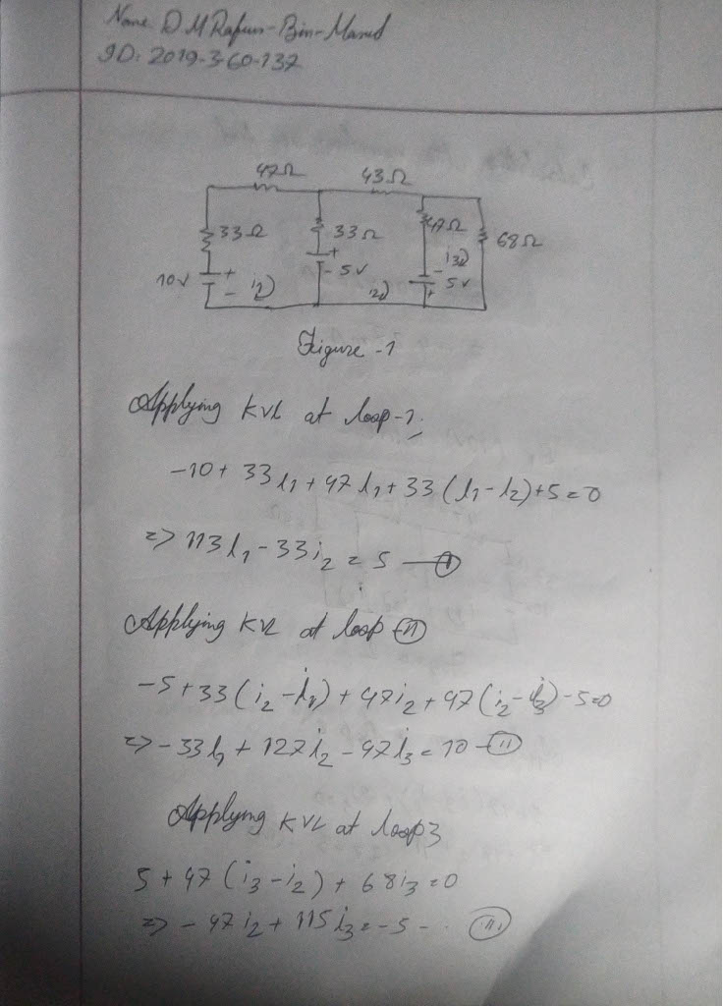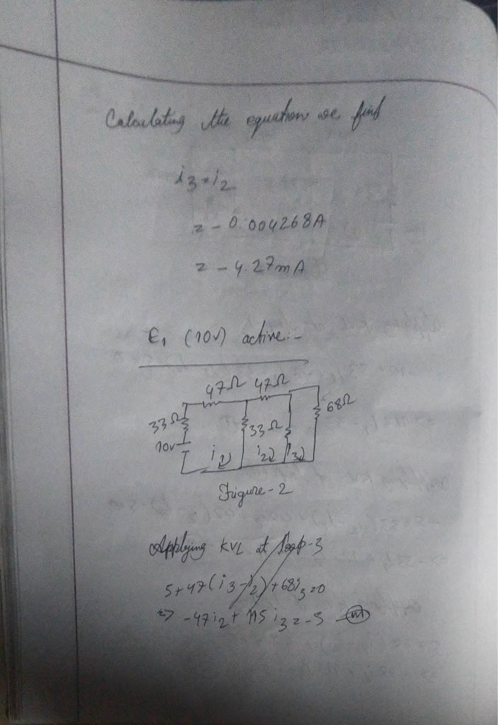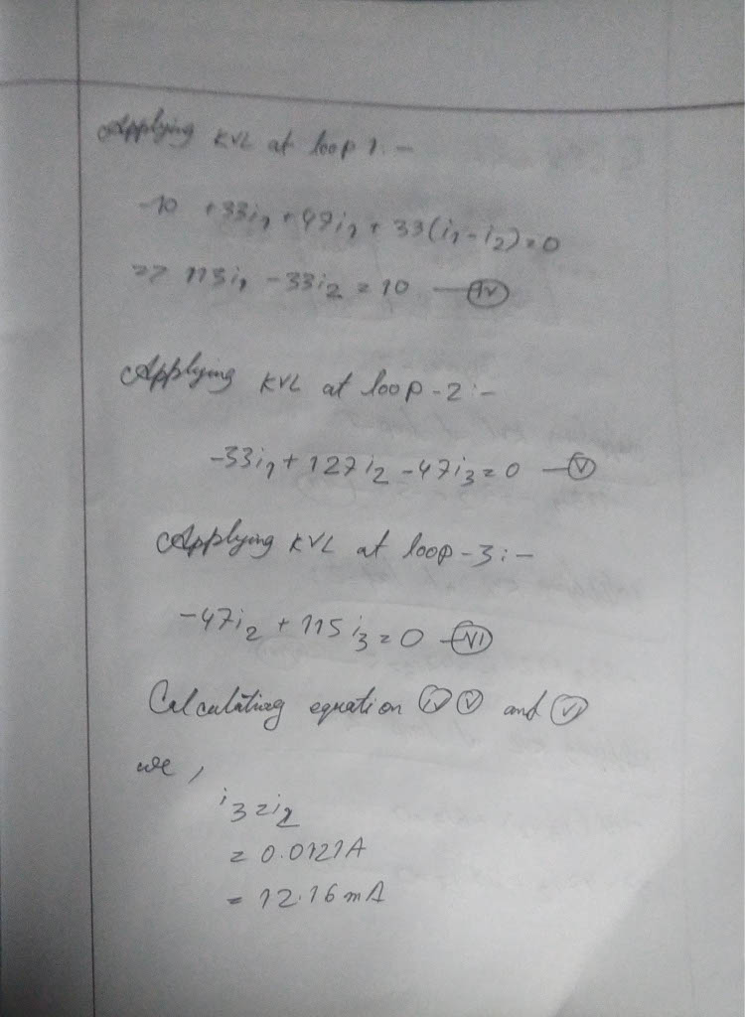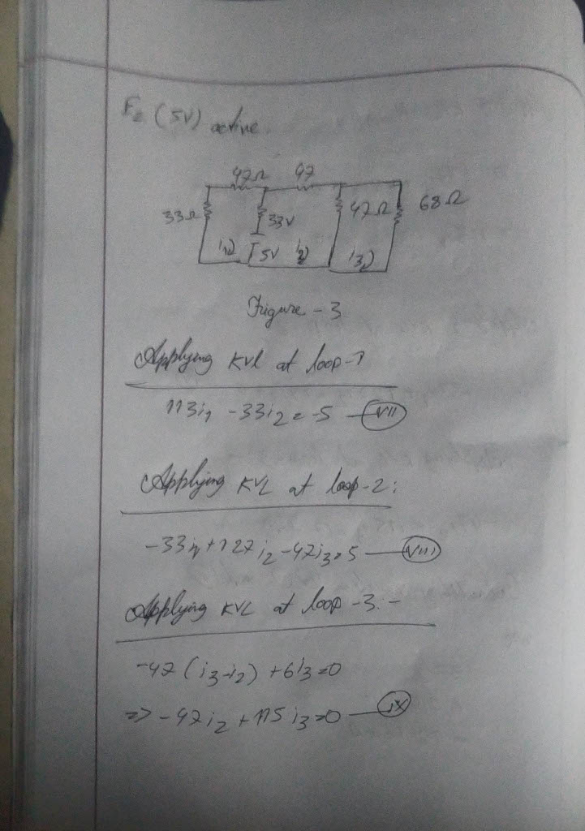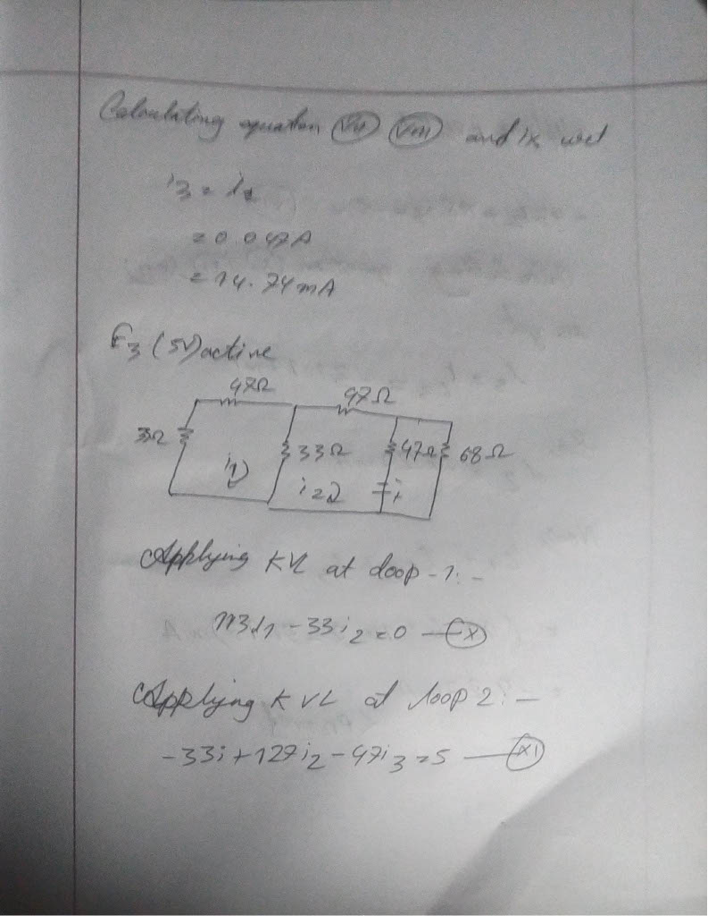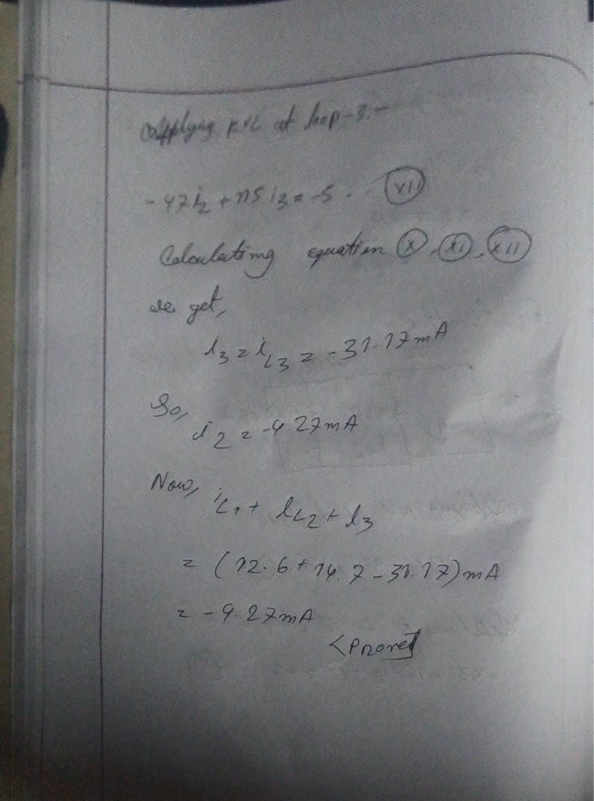

**Result:**

In this experiment we verify the superposition theorem. It is state states in a linear circuit with several sources, the current and voltage for any element in the circuit is the sum of the currents and voltages produced by each source acting independently. We calculate the current with individually voltage source.